James Rumsey Software Proposal

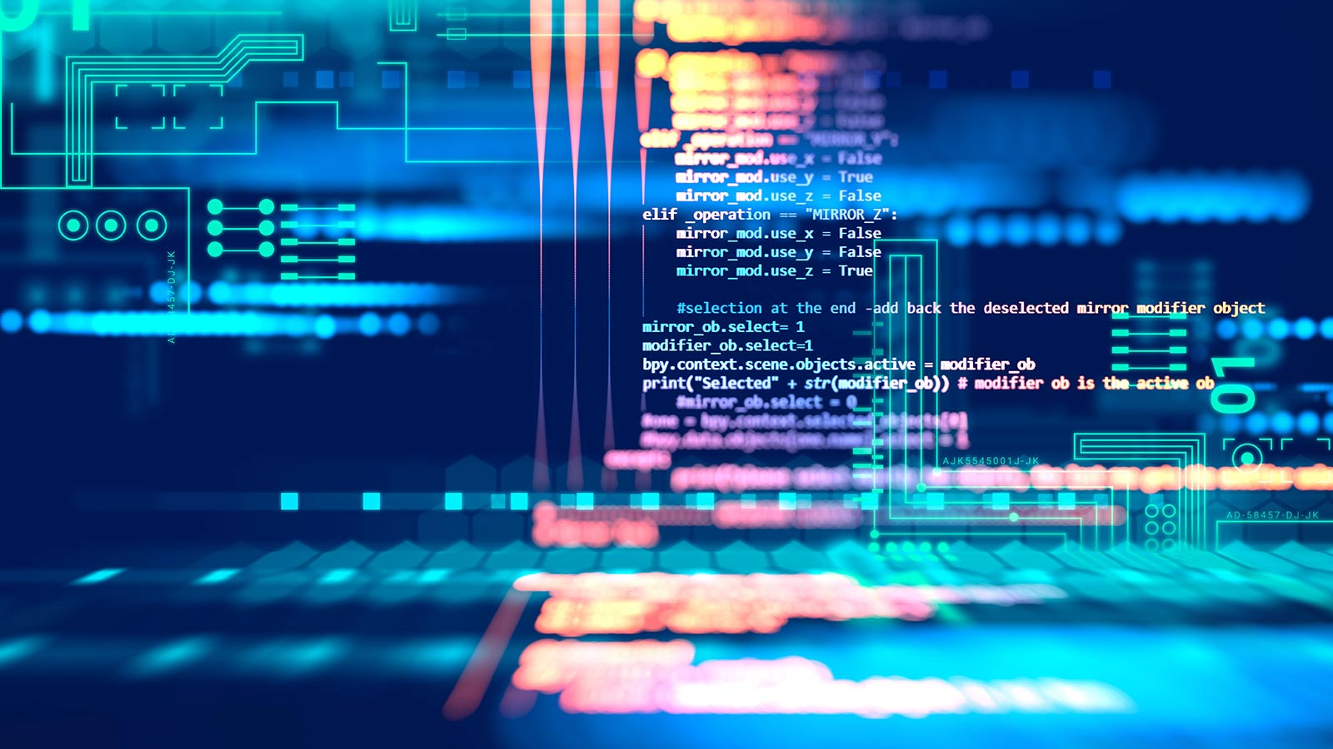

Presented by: Xavier Grubb

Project Name: UnderWorld

Date: 04-16-2021

JRTI Software Development

# James Rumsey Coding – Student Project

## Description of Project

*I plan on creating a mission based multiplayer game where players can log on to a public server party up and go on a variety of missions consisting of kill ___number of enemies, Find the treasure, and more. Players will work together to complete missions to become stronger.*

## Minimum Requirements

All the minimum requirements referenced below will be met by the project.

* This proposal must be approved before any work starts.
* Project will be a minimum of 20 hours of work; if it’s a project you’ve already started, you may use it but explain your plan and estimated hours to update it.
* Hours of work will be recorded on the provided worksheet.
* A post project questionnaire will be answered.
* The code base, images etc will be kept up to date in a github repository shared with me.
* You will create a design document that must be approved before you may start coding.
* Document History
* It must be completed by May 7th
* If you finish early, I may ask you to enhance it.

## Detailed Questions

* What language do you plan on using?

C#

* Will you have a database, if so which one?

While I do plan on having a database later for this, I am sticking to the basics so no database will be present.

* How many hours do you expect this to take?

50hours

* Do you plan on using language features that we have not covered in class, if so, which ones?

I will be using unity, various unity plugins such as mirror, and an amazon server to create this project.

## Make your case

* *I have been working on this project for a month and am passionate about finishing it. While at first, I was planning to do this outside of class this project has given me a chance to take this into the class increasing the time I get to work on the project. This project may seem quite large and ambitious to most, but I have already been devoting my time to the project and have made great headway.*
* I hope to get the basics done by May 7th allowing players to go on missions, setting up a player U.I., and creating enemies the player can fight with other players.
* *I have more experience in unity and am vary passionate towards making games using the platform, and unity is more designed towards the creation of games specially when it comes to multiplayer 3D games such as this one. I am not sure if this project could be done in python and even if so, I would not know where to start.*
* *Currently I have a good portion of mechanics already implemented and have been working towards completing the harder mechanics first. I have downsized the project to the bare bones. I have prepared it so if one mechanic takes too long, I will have a time buffer.*
* *I have done a lot of work with unity this year in and outside of school and am continuing to learn every day. I set out with a single goal for this year to create a 3D game by the end of this school year. I have been spending day after day practicing in unity and learning about it. I know I can make this game by the end of this school year as long I as I do not expand the scope to be too large.*

## Grading

* 10 Points Proposal
* 10 Points Design Document
* 5 Points Github
* 10 Points Interim Review
* 50 Points Project Grade
* 10 Points Program Documentation
* 5 Points Post Project Questionnaire

## Document History

| Status | Date recorded | Issue / Question | Severity | Impact | Resolution |
| --- | --- | --- | --- | --- | --- |
| Open | 4/16/2021 | Initial Version | None | Initial Project | Resolution |
|  | Date 2 | Description | Probability | Impact | Plan |
|  | Date 3 | Description | Probability | Impact | Plan |